**Setup Guarding Vision, Doorbell + Door Stations**

1. Setup the IP scheme, gateway, DNS 1 / 2 correctly.

Ex:

Doorbell: 10.11.100.70

Door Station 1: 10.11.100.71

Door Station 2: 10.11.100.72

2. Open iVMS and ADD the doorbell and door stations.

3. Select the Doorbell and select remote configuration.

4. Navigate to Network -> Local Network Configuration:

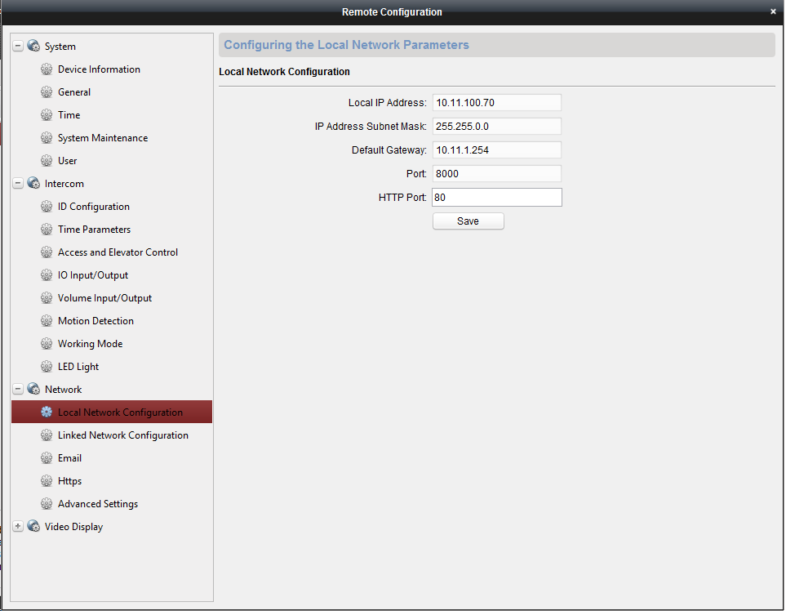

- Make sure settings are correct

5. Navigate to Network -> Advanced Settings:

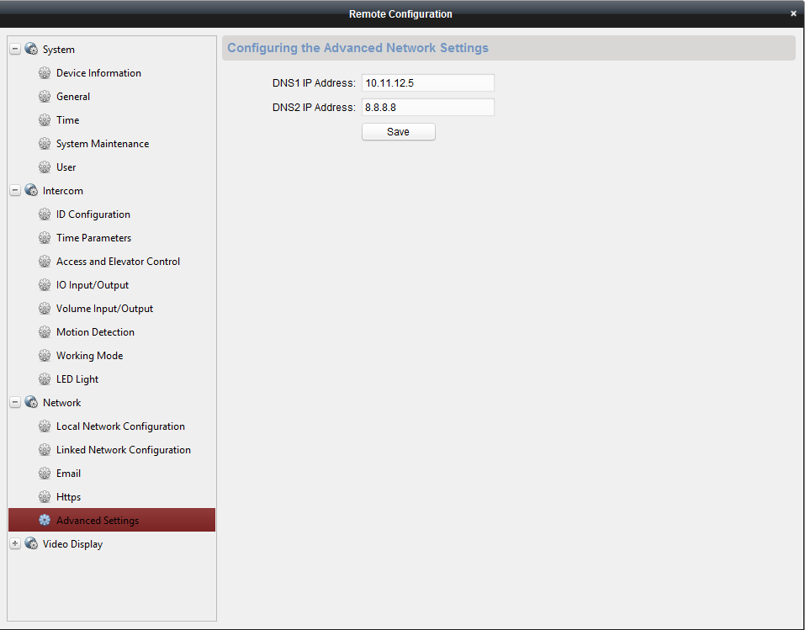

- Make sure settings are correct

6. Navigate to Network -> Linked Network Configuration:

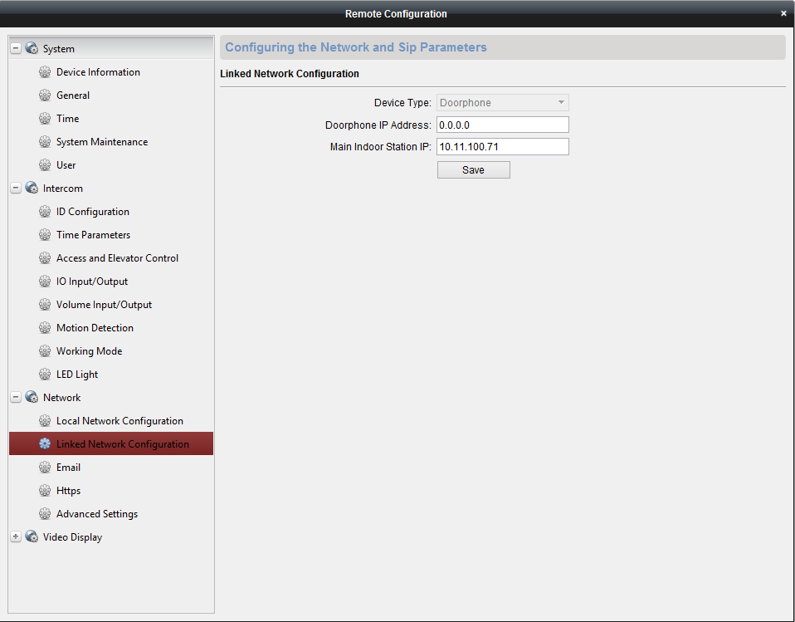

- We are declaring the main door stations static IP address

- So when the door bell is pushed the main door station will ring

**Main Door Station Setup**

1. In iVMS, select the main door station and select remote configuration.

2. Navigate to Network -> Local Network Configuration:

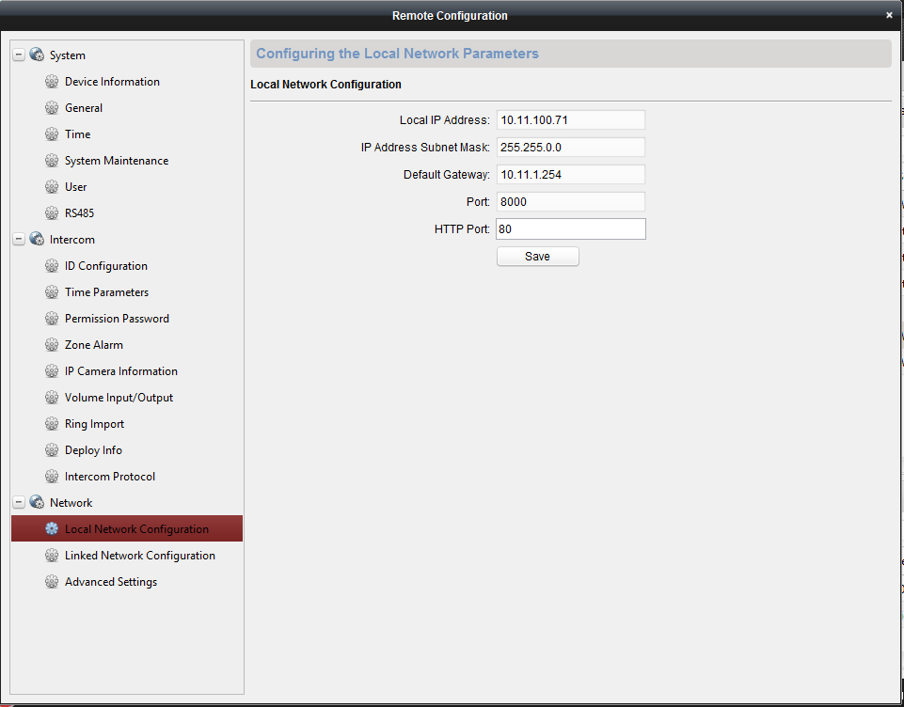- Make sure settings are correct

3. Navigate to Network -> Advanced Settings:

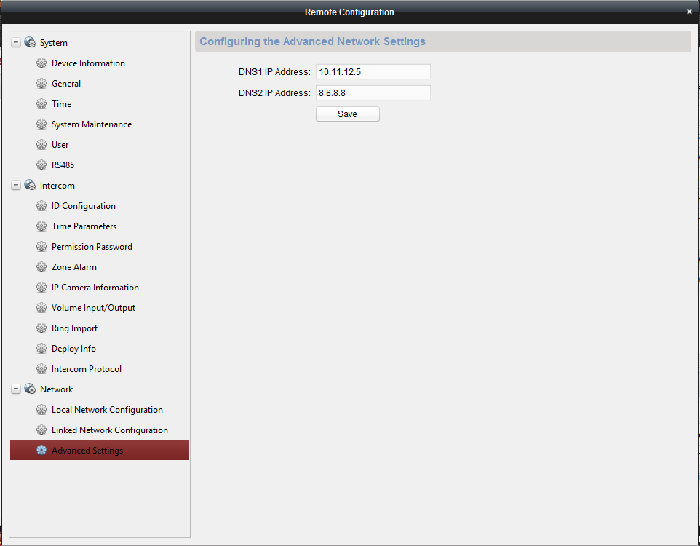- Make sure settings are correct

4. Navigate to Network -> Linked Network Configuration:

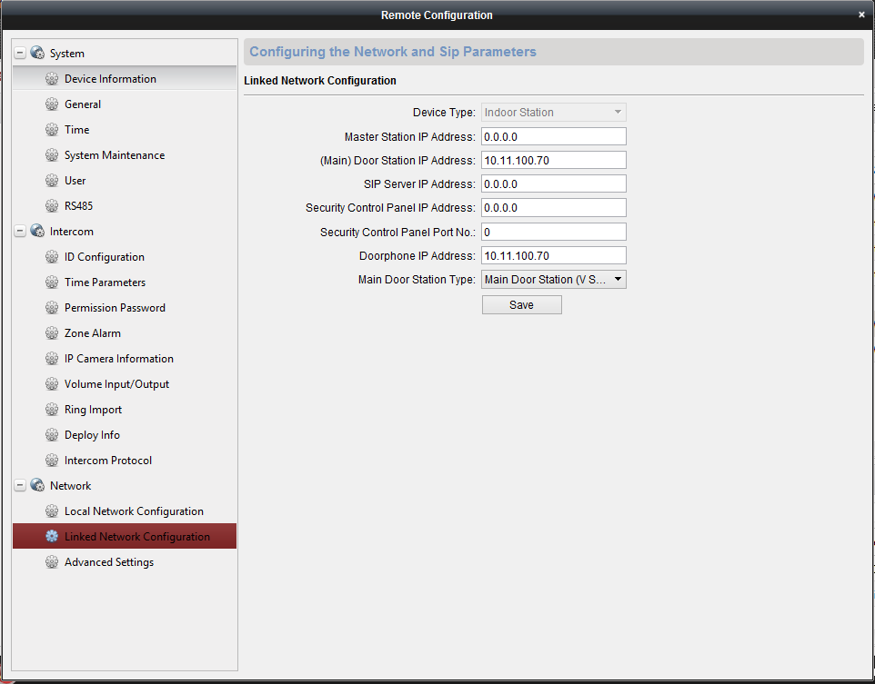

- Here we are changing 3 settings:

1.(Main) Door Station IP Address:

- Door bell IP address goes here (ex: 10.11.100.70)

2. Doorphone IP Address:

- Door bell IP address goes here (ex: 10.11.100.70)

3. Main Door Station Type:

- Select Main Door Station (V Series)

Then SAVE

**Setting up ADDITIONAL Door Stations**

1. In iVMS, select the additional door stations and select remote configuration.

2. Navigate to Network -> Local Network Configuration:

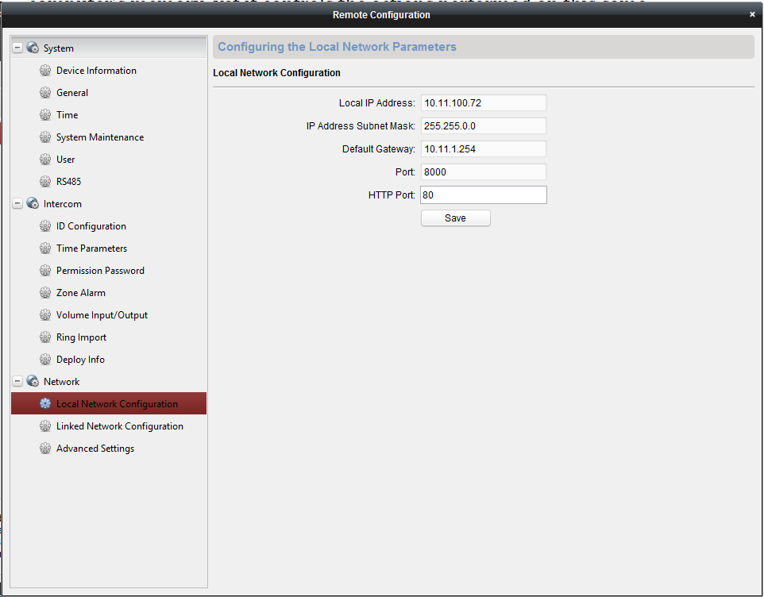- Make sure settings are correct

3. Navigate to Network -> Advanced Settings:

- Make sure settings are correct

4. Next go to the physical door station and select:

- Settings -> Configuration -> Admin PW (888999)

- Under Indoor Station Type -> Select Indoor Extension -> It will prompt to reboot the device.

5. After the device reboots, in iVMS, select the additional door stations and select remote configuration.

6. Navigate to Intercom -> ID Configuration:

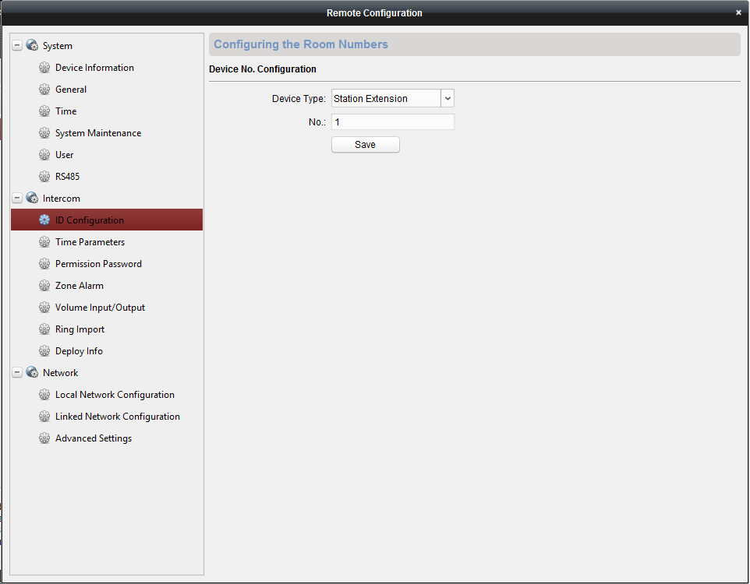

- Declare the station extension number here.

(ex: This is the 1st indoor station that connects to the main indoor station, so we declare it as 1)

7. Navigate to Network -> Linked Network Configuration:

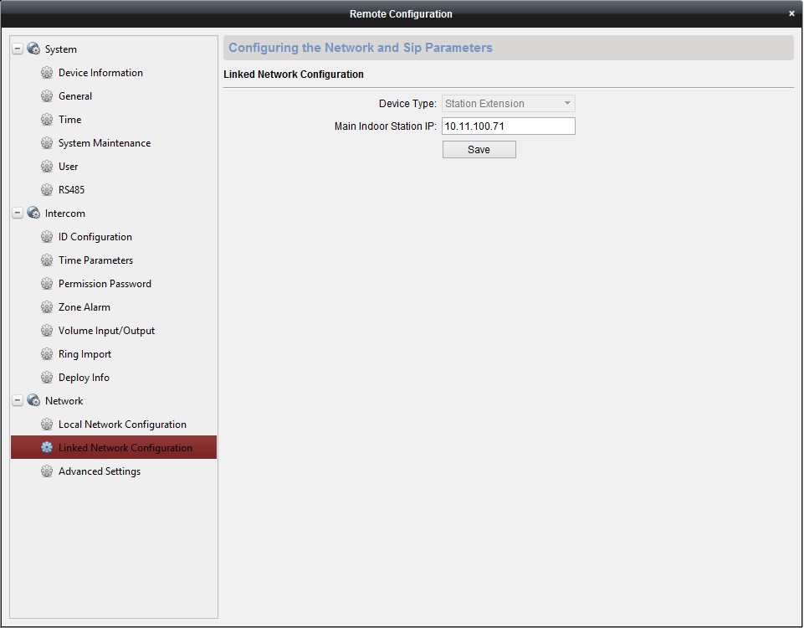

- Main Indoor Station IP: (This is the IP address of the MAIN indoor station)

Then SAVE

**Setting up Guarding Vision**

1. Download the app, setup an account and login

2. Go to guardingvision.com and login

3. Select ADD

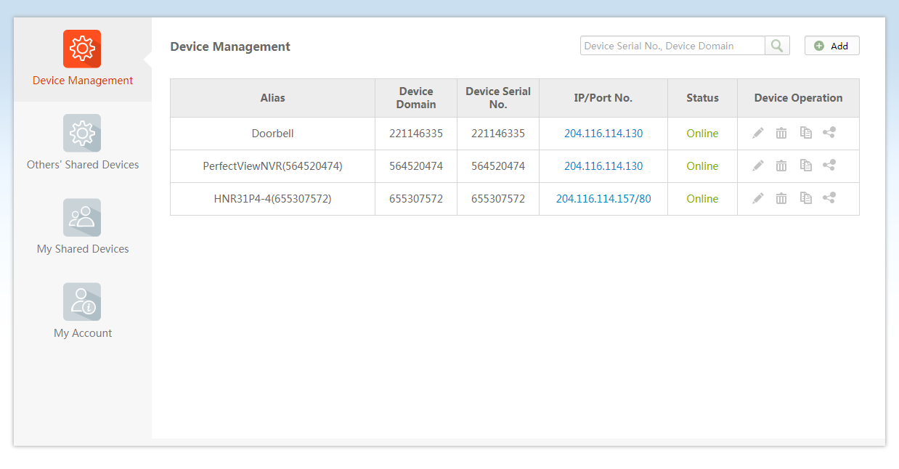

4. The device serial number of the doorbell (Starts after WR and ends before CLU)

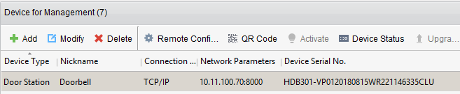

5. Once added you will receive calls on the guarding vision app on the phone